Name:………………………………………………..…. Date:………………………………………………………
Star chemistry
In Autumn 2001 scientists in America announced the discovery of a molecule called 'vinyl alcohol' in the Interstellar Medium (ISM). The structure of this molecule is:
CH₂=CH(OH)
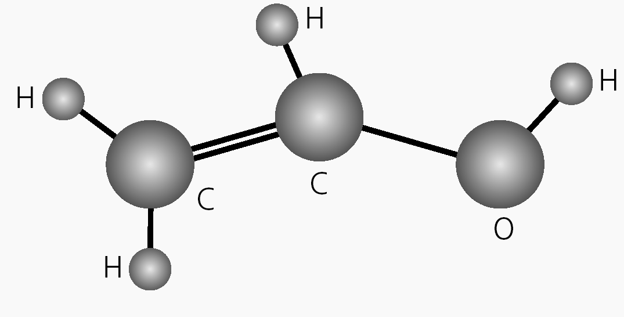
(Reproduced with permission from National Radio Astronomy Observatory/AUI, Virginia, USA.
The discovery of vinyl alcohol
Here is a Press Release from the National Radio Astronomy Observatory in America describing the discovery.
Astronomers using the 12 metre telescope at Kitt Peak, Arizona, USA have discovered the molecule vinyl alcohol in an interstellar cloud of dust and gas near the centre of the Milky Way. The discovery of this long-sought compound could reveal clues to the mysterious origin of large organic molecules in space. Barry Turner, one of the scientists involved said:
'The discovery of vinyl alcohol is significant because it gives us an important tool for understanding the formation of complex organic compounds in interstellar space. It may also help us better understand how life might arise elsewhere in the Cosmos.'
Vinyl alcohol is an important compound in many reactions on Earth. It is the last of three isomers of C₂H₄O to be discovered in the ISM. Turner and his colleagues detected the specific radio signal for vinyl alcohol during May and June 2001. The results will be published in Astrophysical Journal Letters.
Of about 125 molecules detected in the ISM, scientists believe most are formed in gas-phase chemistry in which smaller molecules 'lock horns' when they collide. Although this process makes simple molecules, it does not explain how vinyl alcohol and other complex chemicals are formed in detectable amounts.
Scientists have been searching for the right mechanism to explain how the building blocks for vinyl alcohol and other chemicals are made. Since the 1970s, scientists have suggested that molecules could form on tiny dust grains. The grains trap fast-moving molecules. The dust grain surface acts as a catalyst, like a catalytic converter in a car, enabling the reactions forming the complex molecules to take place. The problem is that the molecules would stay stuck on the grains afterwards, because energy used to knock them off would also destroy the bonds in the molecule.
'This last process has not been well-understood,' explained Turner. 'The current theory explains well how the molecules could form, but not how they leave the grains where they are born.'
continued on next page


Star chemistry
continued from previous page
To get a better understanding, scientists looked at the region of space where the vinyl alcohol was discovered. This is a very energetic area, where lots of stars are being formed. Scientists think the energy melts the icy surfaces of the dust grains, releasing the molecules. The molecules can then be detected by radio antennas on Earth. Turner warns that this is not the
final answer.

'There is another possibility,' says Turner. 'The processes evaporating the ice releases other smaller molecules like methanal and methanol which may react as two gases to give the larger molecules.'
Scientists plan more work to detect other families of isomers which they think will help to determine if molecules form on the grains or in the gas phase.
Questions
1. Use the information section What's in a name? to work out an accurate name for vinyl alcohol.
……………………………………………………………………………………………………………….……………………………………………………………………………………………………………….
……………………………………………………………………………………………………………….
2. What is an 'isomer'? Use the Molecules in space table to find:
- the other isomers of C₂H₄O
……………………………………………………………………………………………………………….
- other isomer 'families' which have been detected.
……………………………………………………………………………………………………………….
3. Mark 'M1' and 'M2' on the sections describing two mechanisms which scientists think produce molecules in space. Why aren't scientists satisfied with the dust grains mechanism?
……………………………………………………………………………………………………………….……………………………………………………………………………………………………………….
……………………………………………………………………………………………………………….
4. Explain why the molecule may give clues to 'life elsewhere in the Cosmos'.
……………………………………………………………………………………………………………….……………………………………………………………………………………………………………….
……………………………………………………………………………………………………………….
continued on next page

Star chemistry
continued from previous page
5. Astrochemistry is a new branch of science. Use the press release to explain what astrochemistry is.
……………………………………………………………………………………………………………….……………………………………………………………………………………………………………….
……………………………………………………………………………………………………………….
6. Find and underline sentences which show:
- another theory explaining how the molecule ends up in space; and
- that scientists do not yet know the 'right' answer about how molecules form in space.
What does this say about science?
……………………………………………………………………………………………………………….……………………………………………………………………………………………………………….
……………………………………………………………………………………………………………….
……………………………………………………………………………………………………………….……………………………………………………………………………………………………………….……………………………………………………………………………………………………………….……………………………………………………………………………………………………………….
……………………………………………………………………………………………………………….
……………………………………………………………………………………………………………….……………………………………………………………………………………………………………….

